***Mark the letter A, B, C or D on your answer sheet to indicate the word whose underlined part differs from the other three in pronunciation in each of the following questions.***

**1.** **A.** notice **B.** ocean **C.** replace **D.** advice

**2.** **A.** dishes **B.** shakes **C.** dances **D.** catches

***Mark the letter A, B, C or D on your answer sheet to indicate the word that differs from the other three in the position of primary stress in each of the following questions.***

**3.** **A.** pursuit **B.** provide **C.** wireless **D.** observe

**4.** **A.** mountainous **B.** optimistic **C.** university **D.** understand

***Mark the letter A, B, C or D on your answer sheet to indicate the correct answer to each of the following questions.***

**5.** My brother is a big fan of Mr. Sherlock Holmes, and he wants to become a ______ like him.

**A.** assembly worker **B.** mechanic

**C.** detective **D.** garment worker

**6.** World Heritage Day ______ on April 18th in many countries worldwide.

**A.** had celebrated **B.** is celebrated

**C.** has celebrated **D.** was celebrated

**7.** Denby Pottery Village still uses some of the original techniques ______ from generation to generation.

**A.** passed down **B.** called off  **C.** passed away **D.** looked up

**8.** No one can ______ the advantages of using computers because they help us ______ our tasks quickly and efficiently.

**A.** deny - do **B.** accept - making **C.** reduce - doing **D.** agree - make

**9.** David and Louis are talking about the air and water quality in their city.

David: “The air and water quality in our city is getting worse and worse.”

Louis: “______”

**A.** I can't agree with you more. **B.** Great! I really appreciate that.

**C.** I think that’s not a matter. **D.** No. You have to remember it.

**10.** The LEICA D-LUX 8 camera, ______ my sister gave me on my birthday, is very beautiful and aesthetic.

**A.** on which **B.** what **C.** which **D.** for which

**11.** Digital products like e-books are gaining ______ because they're convenient and portable.

**A.** population **B.** populate **C.** popular **D.** popularity

**12.** Jeff likes going snowboarding each winter and ______.

**A.** his brother too **B.** his brother does either

**C.** so is his brother **D.** so does his brother

***Read the following announcement and mark the letter A, B, C or D on your answer sheet to indicate the correct option that best fits each of the numbered blanks from 13 to 16.***

| **Trang An Landscape Area’s Ticket Price**  ● An adult ticket is applied (13) ______ a person from 1.3m tall: 250,000 VND/person.  ● For children from 1m to 1.4m tall, the ticket price is: 120,000 VND/child.  ● For children under 1m, it is free of (14) ______.  ● Fee for (15) ______local guide is 300,000 VND/tour.  ● A private boat will be 1,250,000 VND. A boat can (16) ______ 4-5 guests depending on the weight of the group. |
| --- |

**13.** **A.** on **B.** in **C.** for **D.** with

**14. A.** charge **B.** cash **C.** bonus **D.** dept

**15.** **A.** a **B.** an **C.** the **D.** X (no article)

**16.** **A.** return **B.** argue **C.** follow **D.** carry

***Mark the letter A, B, C or D on your answer sheet to indicate the correct answer to each of the following questions from 17 to 18.***

**17. Put the sentences (a-c) in the correct order, then fill in the blank to make a logical text.**

Culture is the lens with which we evaluate everything around us. We evaluate what is proper or improper, normal or abnormal through our culture. _________________.

a. We can learn from each of them if we first understand each other, which helps us work together better.

b. Learning about other cultures also helps us see the world in different ways.

c. Cultural diversity is important because our country, workplaces, and schools have people from many different backgrounds.

**A.** a - b - c **B.** b - c - a **C.** c - a - b **D.** c - b - a

**18. Choose the sentence that can end the text (in Question 17) most appropriately.**

**A.** This is the reason why we should ignore cultural differences.

**B.** By doing so, we become more open-minded and respectful of other cultures.

**C.** However, cultural diversity is more important than just learning about cultures.

**D.** Therefore, we should only focus on our own culture.

***Mark the letter A, B, C or D on your answer sheet to indicate the correct option that best fits each of the numbered blanks from 19 to 24.***

There are lots of reasons why you may want to travel to Vietnam. It’s beautiful, for a start, and its unique culture is amazing. And then, of course, there’s (19) ______ food. Whatever your reason for travelling to Vietnam is, it’s worth (20) ______ about the effect your trip will have – not just on you, but on the places, people and environments you visit, too. Responsible tourism is being (21) ______ the responsibility you have on the destination you’re visiting, and doing your best to make it as positive as possible. The good news is that it’s not hard to practice responsible tourism in Vietnam (22) ______ this country has a wealth of sustainable tourism projects and socially responsible experiences to enjoy. Ecotourism in Vietnam focuses (23) ______ways to enjoy Vietnam’s wonders without destroying them. This style of tourism, (24) ______ is kinder on the environment, helps preserve these places for future travellers. Last but not least, it means that future generations can continue to welcome tourism.

**19.** **A.** any **B.** lot of **C.** many **D.** plenty of

**20.** **A.** think **B.** thinking **C.** to think **D.** to thinking

**21. A.** afraid of **B.** fond of **C.** aware of **D.** proud of

**22.** **A.** because **B.** though **C.** however **D.** therefore

**23.** **A.** in **B.** with **C.** for **D.** on

**24.** **A.** who **B.** whom **C.** which **D.** that

***Mark the letter A, B, C or D on your answer sheet to indicate the sentence that is closest in meaning to the original sentence in each of the following questions.***

**25.** “Students should find a balance between schoolwork and leisure time”, the school counsellor said.

**A.** The school counsellor warned students not to find a balance between schoolwork and leisure time.

**B.** The school counsellor refused students to find a balance between schoolwork and leisure time.

**C.** The school counsellor advised students to find a balance between schoolwork and leisure time.

**D.** The school counsellor admitted students finding a balance between schoolwork and leisure time.

**26.** It is compulsory for all Vietnamese students to learn literature and mathematics.

**A.** All Vietnamese students needn’t learn literature and mathematics.

**B.** All Vietnamese students shouldn’t learn literature and mathematics.

**C.** All Vietnamese students must learn literature and mathematics.

**D.** All Vietnamese students may learn literature and mathematics.

***Mark the letter A, B, C or D on your answer sheet to indicate the sentence that is made from the given cues in each of the following questions.***

**27.** The grammar exercise/ too long/ Nam’s class/ do/ fifteen minutes.

**A.** The grammar exercise was too long for Nam’s class not to do in fifteen minutes.

**B.** The grammar exercise was too long so that Nam’s class could not do it in fifteen minutes.

**C.** The grammar exercise was too long for Nam’s class to do in fifteen minutes.

**D.** The grammar exercise was too long that Nam’s class had to do it in fifteen minutes.

**28.** This/ meaningful/ summer camp/ we/ have.

**A.** This is the most meaningful summer camp that we have ever had.

**B.** This is the more meaningful summer camp than we have ever had.

**C.** This is the most meaningful summer camp that we have never had.

**D.** This is the more meaningful summer camp than we have never had.

***Read the following sign or notice and mark the letter A, B, C or D on your answer sheet to indicate the correct answer to each of the following questions.***

**29.** What does the sign say?



**A.** The sign says that only artists are allowed in the area.

**B.** The sign says that the area is closed due to art activities.

**C.** The sign says that an artist is currently creating art in this area.

**D.** The sign says that people are entering an art gallery.

**30.** What does the notice say?

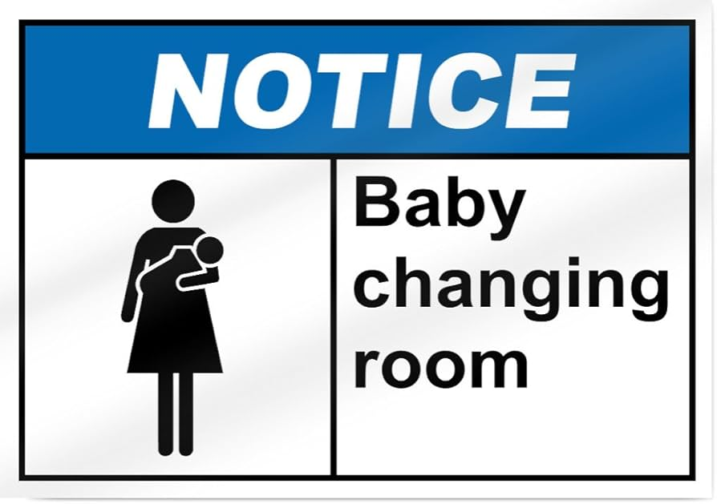

**A.** The notice says that only babies are allowed in the room.

**B.** The notice says that the room is for adults to change their clothes.

**C.** The notice says that the room is for storing baby supplies.

**D.** The notice says that this room is for changing diapers for babies.

***Read the following passage and mark the letter A, B, C or D on your answer sheet to indicate the correct answer to each of the following questions from 31 to 36.***

The building company Hong Kong Housing is building a new suburb in Shanghai, a city with a population of more than 15 million people. But this suburb is not like the other parts of Shanghai. It is a little piece of England. The name of the new area is "English Town". The manager of Hong Kong Housing, Shi Guangsheng, says many people in this area of China want to buy an English house and live in an English town.

This town is like Bristol or Chester. There is an English square and there are pigeons to feed like in Trafalgar Square, London. There are four English-style pubs and you can buy English beer to drink. There is a canal and you can row a boat there like in Cambridge.

Are there any cricket fields? No, there aren't any places to play cricket because nobody in Shanghai can play this game. But there is a football stadium like those in England. And the thing we are very proud of is our shopping street. There are several shops where you can buy **traditional** English food like fish and chips or Christmas Pudding.

The rich Shanghai businessman can do some gardening too. For every house in "English Town", there is an English lawn and there are long gardens with ponds and tall hedges. But there is one problem. The houses in this part of town cost a **minimum** of $400,000!

**31.** What is the main idea of the reading passage?

**A.** Chinese and English houses show completely different styles of architecture.

**B.** Homeowners in this English town benefit from a wide range of public amenities.

**C.** A new building has been built in a Shanghai suburb to showcase Chinese culture.

**D.** Hong Kong Housing company plans to create an English-style suburb in Shanghai.

**32.** How is the new suburb different from the other parts of Shanghai?

**A.** It is located in a rural area far from the city center.

**B.** It is more modern than other parts of the city.

**C.** It is designed to look like a traditional Chinese village.

**D.** It is designed to resemble a traditional English town.

**33.** Which of the following is NOT mentioned in the text as a feature of "English Town"?

**A.** There is a canal where people can row boats, similar to Cambridge.

**B.** This English town's square allows people to feed pigeons like in Trafalgar Square.

**C.** Shops there sell traditional English food like fish and chips or Christmas Pudding.

**D.** The houses in "English Town" are designed in a minimalist style with large windows.

**34.** The word “**traditional**” in paragraph 3 is CLOSEST in meaning to ____________.

**A.** unusual **B.** attractive **C.** classical **D.** impossible

**35.** Why do the developers choose not to include cricket fields in "English Town"?

**A.** They were unable to find enough space to build cricket fields.

**B.** They cannot afford proper cricket fields, so they risk running out of funds.

**C.** They focused only on creating a space for activities like football or shopping.

**D.** They found that cricket is less popular in Shanghai compared to other sports.

**36.** The word “**minimum**” in paragraph 4 is OPPOSITE in meaning to ____________.

**A.** affordable **B.** premium **C.** additional **D.** maximum

***Four phrases/ sentences have been removed from the text below. For each question, mark the letter A, B, C or D on your answer sheet to indicate the correct option that best fits each of the numbered blanks from 37 to 40.***

Scientists and engineers at NASA are working on how we can one day live on Mars. The “Red Planet” as it is sometimes called, is a very different place than Earth. Many of those differences will require new equipment and technology (37) ______ to overcome.

(38) ______. It has only 1/3 of the gravity felt on Earth because it has only 1/10 of Earth’s mass. Humans would need to wear spacesuits to protect them on the surface.

Mars has a much thinner atmosphere than Earth and lacks oxygen for us to breathe. (39) ______. We have (40) ______ at the planet’s poles that tells us Mars probably had rivers and lakes like Earth’s.

**A.** that are being designed and built right now

**B.** found dry lake beds, river beds, and water ice

**C.** Strong winds kick up large dust storms of Mars’s reddish rusty soil.

**D.** NASA uses data collected by rovers and satellites to understand more about how Mars is different.

**37.** ______

**38.** ______

**39.** ______

**40.** ______